1. **Agenda**:
   1. In the last lecture, we created custom AuthenticationProvider.
   2. Now, we will configure/register it with AuthenticationManager.
2. 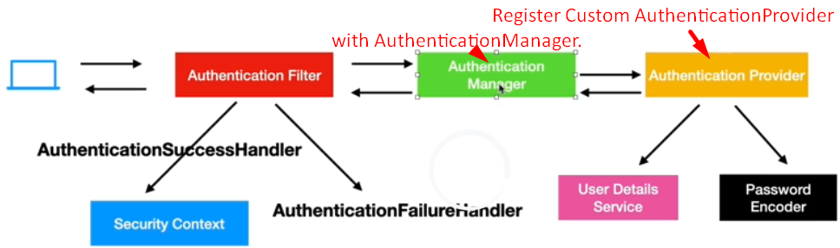
3. 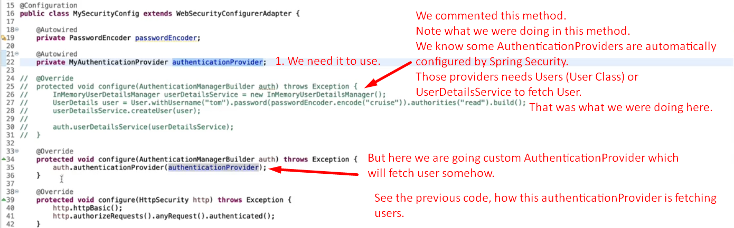
4. 